

**Green University of Bangladesh**

**Department of Computer Science and Engineering (CSE)**

**Semester: (Spring, Year:2024), B.Sc. in CSE (Day)**

**Lab Report NO #04**

**Course Title: Database System Lab**

**Course Code: CSE 210 Section: 221 D1**

**Lab Experiment Name: Implementation of MySQL Aggregate Function**

**Student Details**

| **Name** | | **ID** |
| --- | --- | --- |
| **1.** | Tanvir Ahmed | 221002461 |

**Lab Date : 6/5/2024**

**Submission Date : 13/5/2024**

**Course Teacher’s Name : Dr. Faiz Al Faisal**

| **Lab Report Status**  **Marks: ………………………………… Signature:.....................**  **Comments:.............................................. Date:..............................** |
| --- |

**1. TITLE OF THE LAB REPORT EXPERIMENT**

Implementation of MySQL Aggregate Function.

**2. OBJECTIVES/AIM**

* Gather knowledge about the aggregate function.
* To create a database
* To create tables in the database
* To insert data into each table
* Implement aggregate functions AVG, COUNT, SUM, MIN, MAX, UCASE, LCASE, FLOOR, etc.
* Show the outputs.

**3. PROCEDURE**

* At first, we created a database named employee.
* Then create some tables based on the lab exercise problem.
* Now insert data on each table.
* Do the lab manual tasks.
* Show the outputs of each task.

**4. IMPLEMENTATION**

Lab Task:

Source Code:

1. Input multiple data:

USE Employee;

#CREATE TABLE employees (emp_id int, name varchar(50), age int, job_id varchar(10),dep_id int, salary decimal(8,2));

#CREATE TABLE orders(amount decimal(8,2));

#INSERT INTO employees VALUES (100, 'Steven', 38, 'ad_pres',90,24000),

#(101, 'Neena',48, 'ad_vp',90,17000),

#(102,'Lex',39,'ad_vp',60,17000),

#(103,'Alexander',30,'it_prog',60,9000),

#(107,'Diana',40,'it_prog',100,4200),

#(108,'Nancy',39,'fi_mgr',100,12000),

#(114,'Den',39,'pu_man',30,11000),

#(115,'Khoo',48,'pu_clerk',39,3100);

#CREATE TABLE department(dep_id int,dep_name varchar(30));

#INSERT INTO department VALUES(90,'it'),

#(60,'programmer'),

#(100,'account'),

#(30,'clerk');

#INSERT INTO orders VALUES(200),(400),(200),(400);

1. Write a SQL query for searching employees average age, maximum, and minimum salary:

SELECT AVG(age),MIN(salary),MAX(salary) FROM employees;

Output:



1. Write a SQL statement to find the average purchase amount of all orders:

SELECT AVG(amount) FROM orders;

Output:



1. Implement UCASE, LCASE, MID, FLOOR, CELLING, LENGTH function:

SELECT ucase(salary), lcase(salary), floor(salary), mid(salary,1,3), ceil(salary), length(salary) FROM employees;

Output:

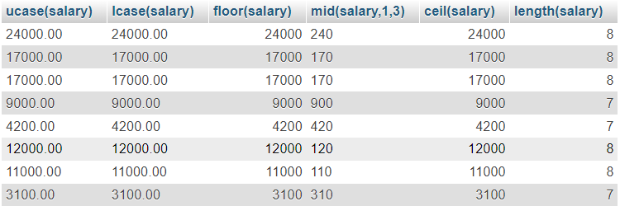

Lab Exercise:

1. Write a query to get the minimum salary from employees table:

SELECT min(salary) FROM employees;

Output:



1. Write a query to get the maximum salary of an employee working as a Programmer:

SELECT max(salary) FROM employees NATURAL join department WHERE dep_name = 'programmer';

Output:



1. Write a query to get the average salary for each job ID excluding programmer:

SELECT avg(salary) FROM employees NATURAL join department WHERE dep_name != 'programmer' GROUP BY dep_id;

Output:

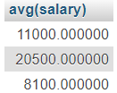

**6. ANALYSIS AND DISCUSSION**

* In this exercise, at first, the database called ‘employee’ was successfully created.
* Then we created some tables based on the lab exercise given in the lab manual.
* I insert information into each table using INSERT INTO statements.
* I perform all the tasks from the lab manual.
* At last, I showed the output.

**7. SUMMARY**

This lab exercise demonstrates practical applications of the SQL aggregate function, especially avg, min, max, sum, and count functions that I learned from the previous class. I implemented the exercise by creating a database, and tables, inserting data into each table, and showing the outputs based on the exercise. The output comes perfectly.